7.2 The products of electrolysis
Name: ____________________ Class: ____________________ Due date: 1.5
1. Which statements about the electrolysis of concentrated copper(II) chloride are correct? （ ）
1 Electrons are transferred from the cathode to the copper(II) ions.
2 Electrons move round the external circuit from the cathode to the anode.
3 Chloride ions are attracted to the anode.
4 Hydroxide ions transfer electrons to the cathode.
A 1 and 3 B 1 and 4 C 2 and 3 D 2 and 4

2. What will be produced at the anode and at the cathode, if molten potassium chloride is electrolysed? （ ）
 | anode (+) | cathode (-)
A | chlorine | hydrogen
B | chlorine | potassium
C | hydrogen | chlorine
D | potassium | chlorine

3. The electrolysis of aqueous copper(II) sulfate, using inert electrodes, is shown.
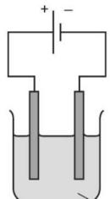
aqueous copper(II) sulfate
Which statement about a reaction at an electrode is correct? （ ）
A Copper ions gain electrons at the negative electrode.
B Copper ions gain electrons at the positive electrode.
C Hydrogen ions gain electrons at the negative electrode.
D Hydrogen ions gain electrons at the positive electrode.

4. The diagram shows the electrolysis of concentrated aqueous sodium chloride.
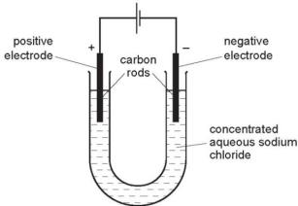
What is produced at each of the electrodes? （ ）
 | product at cathode | product at anode
A | hydrogen | chlorine
B | hydrogen | oxygen
C | sodium | chlorine
D | sodium | oxygen

5. In separate experiments, electricity was passed through concentrated aqueous sodium chloride and molten lead bromide.
What would happen in both experiments? （ ）
A A halogen would be formed at the anode.
B A metal would be formed at the cathode.
C Hydrogen would be formed at the anode.
D Hydrogen would be formed at the cathode.

6. The diagram shows an electrolysis circuit.
At which electrode is hydrogen formed? （ ）
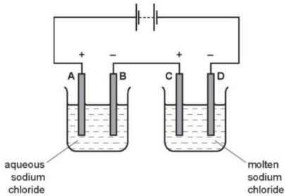
7. Concentrated aqueous sodium chloride, concentrated hydrochloric acid and molten lead bromide were separately electrolysed in experiments 1, 2 and 3.
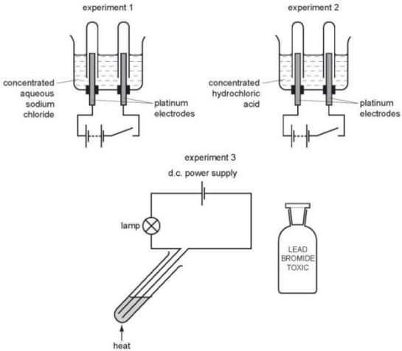
Which statement about the electrode products is correct? （ ）
A Gases were given off at the anode in experiments 2 and 3 only.
B Gases were given off at the cathode in experiments 1 and 2 only.
C Metals were formed at the anode in experiments 1 and 3 only.
D Metals were formed at the cathode in experiments 1 and 3 only.

8. The diagram shows the electrolysis of an aqueous solution of X
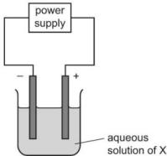
Hydrogen is produced at the cathode and chlorine is produced at the anode.
What is X? （ ）
A concentrated copper(II) chloride solution
B concentrated hydrochloric acid
C dilute hydrochloric acid
D dilute sodium chloride solution
9. Aqueous copper(II) sulfate is electrolysed using carbon electrodes.
What is the product at each electrode? （ ）
 | product at the positive electrode | product at the negative electrode
A | copper | oxygen
B | hydrogen | oxygen
C | oxygen | copper
D | oxygen | hydrogen

10. Two electrolysis experiments were carried out as shown in the diagram below.
The graphite electrodes are labelled 1- 4.
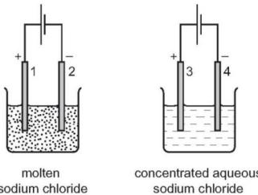
Which row describes the products at the electrodes in these experiments? （ ）
 | electrode 1 | electrode 2 | electrode 3 | electrode 4
A | chlorine | hydrogen | chlorine | hydrogen
B | chlorine | sodium | chlorine | hydrogen
C | chlorine | sodium | hydrogen | chlorine
D | sodium | chlorine | sodium | chlorine
11. Electrolytes can be broken down by electrolysis.
Which rows are correct for each electrolyte? （ ）
 | electrolyte | reaction at cathode | product at anode
1 | dilute aqueous sodium chloride | 2H+ + 2e−→ H₂ | oxygen
2 | concentrated hydrochloric acid | 2H+ + 2e−→ H₂ | chlorine
3 | molten aluminium oxide | 2O₂−→ O₂+ 4e− | aluminium
4 | concentrated aqueous sodium bromide | Na+ + e−→ Na | bromine
A 1 and 2 B 1 and 4 C 2 and 3 D 3 and 4
12. This question is about electrolysis.
a.i.What is meant by the term electrolysis?
...........................................................................................................................................................................................................................................................[2]
ii.Name the type of particle responsible for the conduction of electricity during electrolysis in: the metal wires, the electrolyte
...........................................................................................................................................................................................................................................................[2]
ii.Complete the table.
electrolyte | observation at the anode (+) | name of product at the anode (+) | observation at the cathode (-) | name of product at the cathode (-)
concentrated aqueous potassium chloride |  |  | bubbles of colourless gas
aqueous copper(II) sulfate | bubbles of colourless gas
13. Electrolysis of concentrated aqueous sodium chloride using inert electrodes forms chlorine, hydrogen and sodium hydroxide.
a.Write an ionic half-equation for the formation of hydrogen during this electrolysis.
.............................................................................................................................................................................................................................................................
b.Give the formulae of the four ions present in concentrated aqueous sodium chloride.
..............................................................................................................................
c.Explain how sodium hydroxide is formed during this electrolysis.
.............................................................................................................................................................................................................................................................[2]

14. The diagram below shows the electrolysis of dilute sulfuric acid.
Hydrogen is formed at the negative electrode (cathode) and oxygen at the positive electrode (anode) and the concentration of sulfuric acid increases.
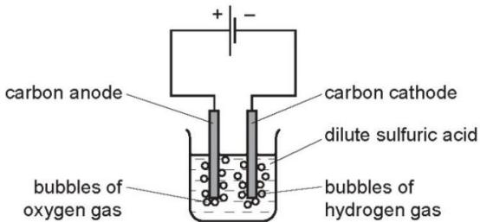
$H^{+}(aq)$${OH}^{−}(aq)$${SO}_{4}^{2−}(aq)$The ions present in the dilute acid are , and .
i.Write an equation for the reaction at the negative electrode (cathode).
ii.Complete the equation for the reaction at the positive electrode (anode).
$$4{OH}^{−}(aq)→O_{2}(g)+……H_{2}O(l)+……$$
iii.Suggest an explanation of why the concentration of the sulfuric acid increases.
.......................................................................................................................................................................................................................................................................... [1]

